

Sogang University

**Using Analytical Hierarchy Process on Selection of Which Fast Food Restaurant to Eat at**

What factors impact this decisions and analyzing the model in depth using Open Decision Maker

Name: Esrat Maria

Student ID: 120190185

Decision Making

Professor Bumsoo Kim

Due Date: Dec 23rd, 2020

***Introduction:***

The fast food franchises focus on meeting the daily expectations of its customers from all walks of life. Nowadays, the fast food franchises are expected to meet the trend which is not only as being the fastest food provider but also by offering a cozy meeting place. In this project my goal is to choose which restaurant to have dinner at while evaluating some criteria. The decision making has been done using **Analytical Hierarchy Process** (AHP). By evaluating some criteria like customer service, food price, facilities, location, and cleanliness my goal is to finding out the optimal decision by using the AHP method.

The fast food chains that I am considering to formulate the AHP model are KFC, Burger King, McDonalds, and Mom’s Touch. The optimal decision would be among these 4 fast food chains to have dinner at considering the above mentioned criteria.

Goal:

* To identify the priority of decision criteria in the selection of fast food restaurant with Analytical Hierarchy Process (AHP) Model.
* To determine the most preferred fast food restaurant among KFC, Burger King, McDonalds, and Mom’s Touch.

***What is AHP?***

AHP stands for analytic hierarchy process, and belongs to the multi-criteria decision making methods (MCDM). In AHP, values like price, weight, or area, or even subjective opinions such as feelings, preferences, or satisfaction, can be translated into measurable numeric relations. The core of AHP is the comparison of pairs instead of sorting (ranking), voting (e.g. assigning points) or the free assignment of priorities.

AHP has been used successfully in many institutions and companies. Although the method is so universal, it is still simple enough to execute in Excel. One of AHP’s great advantages is the ability to use it for group decisions, in which all participants evaluate pairs and the group result is determined as the mathematically optimum consensus.

As it can be seen in the picture below the main components of an AHP model are Goal - -> Criteria - - > Sub-criteria - - > Alternatives.

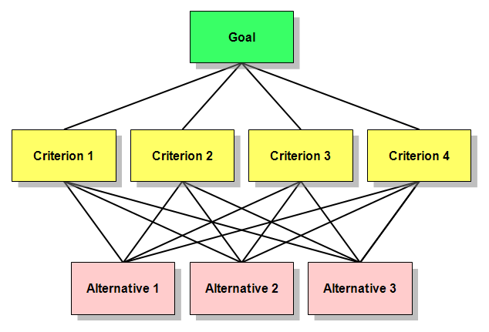

Fig: Components of an AHP model

***Preparation of the AHP model:***

As stated above I have considering 5 criteria like customer service, food price, facilities, location, and cleanliness and my alternatives are KFC, Burger King, McDonalds, and Mom’s Touch. My AHP modle structure look like below:

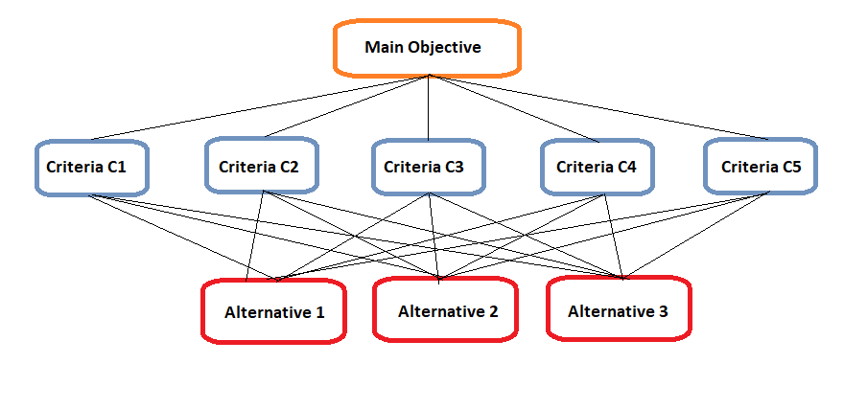

Fig: AHP model for choosing the restaurant to have dinner at.

Decision alternatives: **KFC (A1), Burger King (A2), McDonalds (A3), and Mom’s Touch (A4).**

Decision Criteria: **Customer service (C1), food price (C2), facilities (C3), location (C4), and cleanliness (C5).**

***Data Collection:***

To collect the data about where people prefer to dine in I performed a survey. The survey was participated by 10 people who are in my lab. Questionnaires have been constructed and distributed among these 10 people. For each question they were requested to compare between criteria and compare the relative fast food restaurant according to each criterion.

A scale was constructed for convenience and to easily collect data from the participants. For each criteria the participants were asked to put their level of preference. The scale has been described below:

|  |  |
| --- | --- |
| Numerical Value | Preference Level |
| 1 | **Equally preferred** |
| 2 | **Equally to moderately preferred** |
| 3 | **Moderately preferred** |
| 4 | **Moderately to strongly preferred** |
| 5 | **Strongly preferred** |
| 6 | **Strongly to very strongly preferred** |
| 7 | **Very strongly preferred** |
| 8 | **Very strongly to extremely preferred** |
| 9 | **Extremely preferred** |

Table: Preference Scale

***Model Formation:***

Since we have 5 criteria so, n = 5. Now the number of comparison should be $\frac{n\left(n-1\right)}{2}$ i.e. 10. I have 10 comparisons to make.

1 = Equal 5 = Strong

3 = Moderate 7 = Very Strong 9 = Extreme

|  |  |  |  |  |  |  |  |  |  |  |  |  |  |  |  |  |  |  |  |  |
| --- | --- | --- | --- | --- | --- | --- | --- | --- | --- | --- | --- | --- | --- | --- | --- | --- | --- | --- | --- | --- |
| **Criteria 1** | | **Evaluation** | | | | | | | | | | | | | | | | | | **Criteria 2** |
| 1 | **Customer service** | 9 | 8 | 7 | 6 | 5 | 4 | 3 | 2 | 1 | 2 | 3 | 4 | 5 | 6 | 7 | 8 | 9 | **Price** | |
| 2 | **Customer service** | 9 | 8 | 7 | 6 | 5 | 4 | 3 | 2 | 1 | 2 | 3 | 4 | 5 | 6 | 7 | 8 | 9 | **Facilities** | |
| 3 | **Customer service** | 9 | 8 | 7 | 6 | 5 | 4 | 3 | 2 | 1 | 2 | 3 | 4 | 5 | 6 | 7 | 8 | 9 | **Location** | |
| 4 | **Customer service** | 9 | 8 | 7 | 6 | 5 | 4 | 3 | 2 | 1 | 2 | 3 | 4 | 5 | 6 | 7 | 8 | 9 | **Cleanliness** | |
| 5 | **Price** | 9 | 8 | 7 | 6 | 5 | 4 | 3 | 2 | 1 | 2 | 3 | 4 | 5 | 6 | 7 | 8 | 9 | **Facilities** | |
| 6 | **Price** | 9 | 8 | 7 | 6 | 5 | 4 | 3 | 2 | 1 | 2 | 3 | 4 | 5 | 6 | 7 | 8 | 9 | **Location** | |
| 7 | **Price** | 9 | 8 | 7 | 6 | 5 | 4 | 3 | 2 | 1 | 2 | 3 | 4 | 5 | 6 | 7 | 8 | 9 | **Cleanliness** | |
| 8 | **Facilities** | 9 | 8 | 7 | 6 | 5 | 4 | 3 | 2 | 1 | 2 | 3 | 4 | 5 | 6 | 7 | 8 | 9 | **Location** | |
| 9 | **Facilities** | 9 | 8 | 7 | 6 | 5 | 4 | 3 | 2 | 1 | 2 | 3 | 4 | 5 | 6 | 7 | 8 | 9 | **Cleanliness** | |
| 10 | **Location** | 9 | 8 | 7 | 6 | 5 | 4 | 3 | 2 | 1 | 2 | 3 | 4 | 5 | 6 | 7 | 8 | 9 | **Cleanliness** | |

Fig: Comparison between criteria

To collect data from the participants I made the following chart that compare the relative restaurants according to the above mentioned criteria. The participants were asked to give their inputs by circling one number per row by using the preference scale stated before. That chart that they were asked to fill in looks like below:

|  |  |  |  |  |  |  |  |  |  |  |  |  |  |  |  |  |  |  |  |
| --- | --- | --- | --- | --- | --- | --- | --- | --- | --- | --- | --- | --- | --- | --- | --- | --- | --- | --- | --- |
| **Criteria 1 (C1) Customer Service** | | | | | | | | | | | | | | | | | | | |
| 1 | **KFC** | 9 | 8 | 7 | 6 | 5 | 4 | 3 | 2 | 1 | 2 | 3 | 4 | 5 | 6 | 7 | 8 | 9 | **Burger King** |
| 2 | **KFC** | 9 | 8 | 7 | 6 | 5 | 4 | 3 | 2 | 1 | 2 | 3 | 4 | 5 | 6 | 7 | 8 | 9 | **McDonalds** |
| 3 | **KFC** | 9 | 8 | 7 | 6 | 5 | 4 | 3 | 2 | 1 | 2 | 3 | 4 | 5 | 6 | 7 | 8 | 9 | **Mom’s Touch** |
| 3 | **Burger King** | 9 | 8 | 7 | 6 | 5 | 4 | 3 | 2 | 1 | 2 | 3 | 4 | 5 | 6 | 7 | 8 | 9 | **McDonalds** |
| 3 | **Burger King** | 9 | 8 | 7 | 6 | 5 | 4 | 3 | 2 | 1 | 2 | 3 | 4 | 5 | 6 | 7 | 8 | 9 | **Mom’s Touch** |
| 3 | **McDonalds** | 9 | 8 | 7 | 6 | 5 | 4 | 3 | 2 | 1 | 2 | 3 | 4 | 5 | 6 | 7 | 8 | 9 | **Mom’s Touch** |

|  |  |  |  |  |  |  |  |  |  |  |  |  |  |  |  |  |  |  |  |
| --- | --- | --- | --- | --- | --- | --- | --- | --- | --- | --- | --- | --- | --- | --- | --- | --- | --- | --- | --- |
| **Criteria 2 (C2) Price** | | | | | | | | | | | | | | | | | | | |
| 1 | **KFC** | 9 | 8 | 7 | 6 | 5 | 4 | 3 | 2 | 1 | 2 | 3 | 4 | 5 | 6 | 7 | 8 | 9 | **Burger King** |
| 2 | **KFC** | 9 | 8 | 7 | 6 | 5 | 4 | 3 | 2 | 1 | 2 | 3 | 4 | 5 | 6 | 7 | 8 | 9 | **McDonalds** |
| 3 | **KFC** | 9 | 8 | 7 | 6 | 5 | 4 | 3 | 2 | 1 | 2 | 3 | 4 | 5 | 6 | 7 | 8 | 9 | **Mom’s Touch** |
| 3 | **Burger King** | 9 | 8 | 7 | 6 | 5 | 4 | 3 | 2 | 1 | 2 | 3 | 4 | 5 | 6 | 7 | 8 | 9 | **McDonalds** |
| 3 | **Burger King** | 9 | 8 | 7 | 6 | 5 | 4 | 3 | 2 | 1 | 2 | 3 | 4 | 5 | 6 | 7 | 8 | 9 | **Mom’s Touch** |
| 3 | **McDonalds** | 9 | 8 | 7 | 6 | 5 | 4 | 3 | 2 | 1 | 2 | 3 | 4 | 5 | 6 | 7 | 8 | 9 | **Mom’s Touch** |

|  |  |  |  |  |  |  |  |  |  |  |  |  |  |  |  |  |  |  |  |
| --- | --- | --- | --- | --- | --- | --- | --- | --- | --- | --- | --- | --- | --- | --- | --- | --- | --- | --- | --- |
| **Criteria 3 (C3) Facilities** | | | | | | | | | | | | | | | | | | | |
| 1 | **KFC** | 9 | 8 | 7 | 6 | 5 | 4 | 3 | 2 | 1 | 2 | 3 | 4 | 5 | 6 | 7 | 8 | 9 | **Burger King** |
| 2 | **KFC** | 9 | 8 | 7 | 6 | 5 | 4 | 3 | 2 | 1 | 2 | 3 | 4 | 5 | 6 | 7 | 8 | 9 | **McDonalds** |
| 3 | **KFC** | 9 | 8 | 7 | 6 | 5 | 4 | 3 | 2 | 1 | 2 | 3 | 4 | 5 | 6 | 7 | 8 | 9 | **Mom’s Touch** |
| 3 | **Burger King** | 9 | 8 | 7 | 6 | 5 | 4 | 3 | 2 | 1 | 2 | 3 | 4 | 5 | 6 | 7 | 8 | 9 | **McDonalds** |
| 3 | **Burger King** | 9 | 8 | 7 | 6 | 5 | 4 | 3 | 2 | 1 | 2 | 3 | 4 | 5 | 6 | 7 | 8 | 9 | **Mom’s Touch** |
| 3 | **McDonalds** | 9 | 8 | 7 | 6 | 5 | 4 | 3 | 2 | 1 | 2 | 3 | 4 | 5 | 6 | 7 | 8 | 9 | **Mom’s Touch** |

|  |  |  |  |  |  |  |  |  |  |  |  |  |  |  |  |  |  |  |  |
| --- | --- | --- | --- | --- | --- | --- | --- | --- | --- | --- | --- | --- | --- | --- | --- | --- | --- | --- | --- |
| **Criteria 4 (C4) Location** | | | | | | | | | | | | | | | | | | | |
| 1 | **KFC** | 9 | 8 | 7 | 6 | 5 | 4 | 3 | 2 | 1 | 2 | 3 | 4 | 5 | 6 | 7 | 8 | 9 | **Burger King** |
| 2 | **KFC** | 9 | 8 | 7 | 6 | 5 | 4 | 3 | 2 | 1 | 2 | 3 | 4 | 5 | 6 | 7 | 8 | 9 | **McDonalds** |
| 3 | **KFC** | 9 | 8 | 7 | 6 | 5 | 4 | 3 | 2 | 1 | 2 | 3 | 4 | 5 | 6 | 7 | 8 | 9 | **Mom’s Touch** |
| 3 | **Burger King** | 9 | 8 | 7 | 6 | 5 | 4 | 3 | 2 | 1 | 2 | 3 | 4 | 5 | 6 | 7 | 8 | 9 | **McDonalds** |
| 3 | **Burger King** | 9 | 8 | 7 | 6 | 5 | 4 | 3 | 2 | 1 | 2 | 3 | 4 | 5 | 6 | 7 | 8 | 9 | **Mom’s Touch** |
| 3 | **McDonalds** | 9 | 8 | 7 | 6 | 5 | 4 | 3 | 2 | 1 | 2 | 3 | 4 | 5 | 6 | 7 | 8 | 9 | **Mom’s Touch** |

Fig: User input containing comparison of restaurants with each criteria

|  |  |  |  |  |  |  |  |  |  |  |  |  |  |  |  |  |  |  |  |
| --- | --- | --- | --- | --- | --- | --- | --- | --- | --- | --- | --- | --- | --- | --- | --- | --- | --- | --- | --- |
| **Criteria 5 (C5) Cleanliness** | | | | | | | | | | | | | | | | | | | |
| 1 | **KFC** | 9 | 8 | 7 | 6 | 5 | 4 | 3 | 2 | 1 | 2 | 3 | 4 | 5 | 6 | 7 | 8 | 9 | **Burger King** |
| 2 | **KFC** | 9 | 8 | 7 | 6 | 5 | 4 | 3 | 2 | 1 | 2 | 3 | 4 | 5 | 6 | 7 | 8 | 9 | **McDonalds** |
| 3 | **KFC** | 9 | 8 | 7 | 6 | 5 | 4 | 3 | 2 | 1 | 2 | 3 | 4 | 5 | 6 | 7 | 8 | 9 | **Mom’s Touch** |
| 3 | **Burger King** | 9 | 8 | 7 | 6 | 5 | 4 | 3 | 2 | 1 | 2 | 3 | 4 | 5 | 6 | 7 | 8 | 9 | **McDonalds** |
| 3 | **Burger King** | 9 | 8 | 7 | 6 | 5 | 4 | 3 | 2 | 1 | 2 | 3 | 4 | 5 | 6 | 7 | 8 | 9 | **Mom’s Touch** |
| 3 | **McDonalds** | 9 | 8 | 7 | 6 | 5 | 4 | 3 | 2 | 1 | 2 | 3 | 4 | 5 | 6 | 7 | 8 | 9 | **Mom’s Touch** |

***Evaluation:***

After collecting all the values from the 10 participants I used an open source software called “**Open Decision Maker**” to analyze the AHP model. I figured out the weights of each criteria and which fast food restaurant is more popular among the participants.

The inputs (as stated in the tables above) from participants were put in the software and the final results were given. The analyzation of the produced result has been discussed below.

The weights of each criteria according to user input came out as follows:

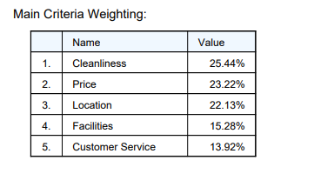

From the above image it look like cleanliness is the most important factor when it comes to take a decision on where to eat. Price is the second most important factor as seen on the table.

The Alternative/Criterion matrix from user input looks like below:

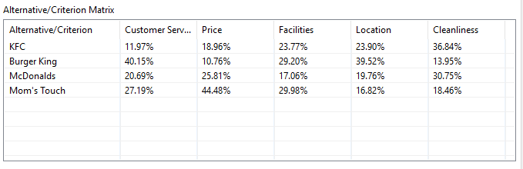

From the above image it can be seen that **KFC** is leading in terms of **Cleanliness**. **McDonalds** got a very distributed outputs in terms of criteria. Even if **Burger** **King** is excelling in **Customer** **Service** and **Location**, **Mom’s** **Touch** beats this record in terms of **Price**, **Facilities** and **Cleanliness** while compared with **Burger** **King**. The ranking for each criteria is given below as found using **ODM**.

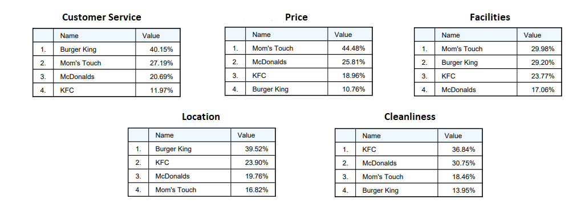

Fig: Criterion Ranking

In this project, to build the AHP model aggregation of individual priorities was used. Meaning, individuals are acting in his or her own right with different value systems.

There has been another observation during analyzation. It has been seen that there are some inconsistency in ration while it comes to criteria like **Facilities** and **Cleanliness**. The consistency ratio for both **Facilities** and **Cleanliness** is 0.11. This could be due to the fact that these are qualitative criteria.

Finally, from the above analysis it has been found that participants are more likely to dine at **Mom’s Touch**. **Mom’s** **Touch** is leading in the participant’s preference list. So, students are more like to choose **Mom’s** **Touch** for dinner rather than any other fast food restaurants.

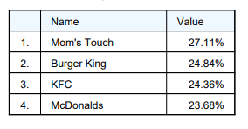

Fig: Restaurant preference ranking